Nathan, Salisbury, Moorooka Neighbourhood Plan — Summary of online feedback

BACKGROUND RESEARCH PHASE • DECEMBER 2019

Brisbane City Council is creating the Nathan, Salisbury, Moorooka Neighbourhood Plan. Council asked the local community for initial ideas and input from 26 August to 6 October 2019, in order to understand the key issues that are important to future planning for the area. Thanks to all of those who placed a pin on the interactive map or completed a survey. This snapshot summarises those responses.

Interactive map

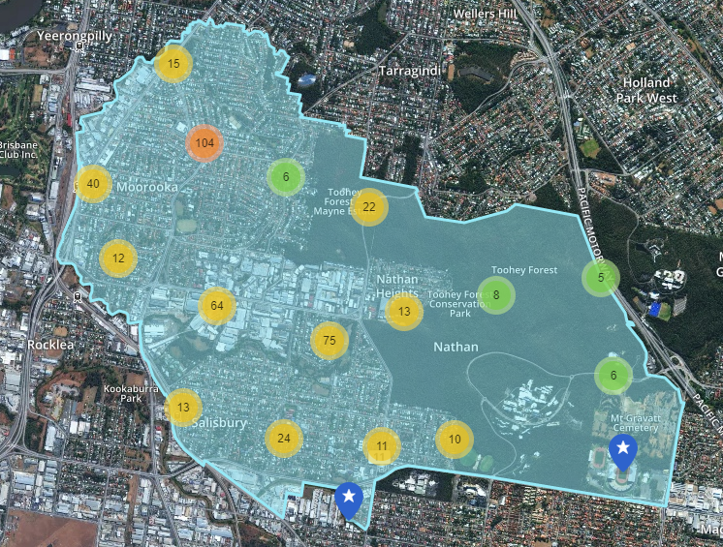
About the interactive map
Council received 430 responses to the interactive map. People had the opportunity to have their say on places to ‘Stay the same’ or potential opportunities for improvement by identifying places that are ‘Suitable for growth or change’ within the plan area. Approximately 115 responses were received for places to ‘Stay the same’ and 315 responses for ‘Suitable for growth or change’ on the interactive map.

Places to stay the same in the plan area
- The wildlife and nature of Toohey Forest.
- Heritage buildings and character housing, particularly the Clifton Hill War Service Homes Estate.
- Local parks and open space areas.
- Local cafes and businesses.

Opportunities for improvements in the area
- The amenity and functionality of local parks.
- Pedestrian connections and crossings, particularly across major roads in Moorooka and Salisbury, such as Ipswich Road.
- Bicycle paths and connections towards the city, Griffith University and Oxley.
- Pedestrian and public transport connections to Griffith University Nathan Campus.
- A wider variety of services and retail and dining uses at Moorooka shops and Toohey Road shops.
- Potential for different land uses along the Moorooka Magic Mile and around Moorooka and Salisbury train stations.
- Impacts from industrial uses on residential areas.
- Providing for wildlife crossings on major roads around Toohey Forest.
- Greenspace and water quality along Rocky Waterholes Creek, Stable Swamp Creek and Moolabin Creek.

Online survey

About the online survey
Council received 757 completed responses to the survey with a good response rate across the plan area — Moorooka (45%), Salisbury (34%), Nathan (7%) and other areas (13%). Over 80% of the respondents lived in the plan area. Of the respondents who lived or owned a property in the plan area, 44% had been there for 10 years or longer. Of those who worked or owned a business in the plan area, 37% had done so for up to three years and 34% had done so for 10 years or more.

Locals value
- Parks and greenspace such as Toohey Forest.
- Proximity to Brisbane City Centre.
- Access to public transport.
- Sense of community.
- Recreation activities such as walking and cycling.
- Safe neighbourhood.

Suggested improvements for the area
- More or improved cafes, dining, shops, markets.
- More or improved recreation, greenspace, parks and playgrounds.
- Streetscape improvements.
- Pedestrian and cycle paths.
- More trees and shade.
- Public transport improvements.

Getting around
- Most people use their cars (55%) or walk (35%) to local cafes and entertainment, and most people drive to shops and services.
- Concerns were raised about the availability of car parking, particularly around local shopping precincts such as the Moorooka shops.
- A need for safer crossings and connected pedestrian and cycle paths was identified.
- A desire for more frequent public transport services and easy access to key destinations, such as to the Griffith University Nathan Campus.

Housing choice
- A variety of views were expressed about housing choices in the plan area.
- Most people (55%) thought there was ‘just the right’ amount of stand-alone houses in the plan area.
- Some people thought there were ‘too many’ apartments (44%) or townhouses (31%) in the plan area, whilst 30% of people thought more mixed residential and commercial units were required.
- Character housing is highly valued, including the Clifton Hill and Goodwin Terrace areas in Moorooka.
- It was suggested a mix of residential and commercial buildings near train stations would make better use of the transport networks.
- 29% of people identified a need for more aged care accommodation in the plan area.

Lifestyle and recreation
- The local shopping and dining options are used on a weekly basis and local businesses are highly valued.
- Parks and greenspaces are highly valued, and there are opportunities to improve facilities and functionality.
- Toohey Forest is highly valued for its wildlife, bushland and recreation opportunities.

Moorooka shopping precinct
- 71% of people use the Moorooka shopping precinct on Beaudesert Road.
- The attractiveness of the Moorooka shopping precinct was rated an average of 5.1 out of 10, and the vibrancy of the Moorooka shopping precinct was rated an average of 5.5 out of 10.
- Recommendations to improve the attractiveness and vibrancy of the shopping precinct include introducing a diverse range of retail uses, landscaping and greenery, improvements to footpaths, lighting and street furniture, and parking availability.

Moorooka Magic Mile
- Many people considered the Moorooka Magic Mile to be unattractive and there were opportunities to use the land in different ways.
- The contribution of the Moorooka Magic Mile to the local area was rated an average of 4.3 out of 10.
- Recommendations to improve the Moorooka Magic Mile include a more diverse range of uses such as retail, residential and entertainment, and aesthetic improvements such as landscaping.

Industrial areas
- Residents in close proximity to industrial areas are affected by pollution from industrial activities.
- Some people thought the existing industrial precincts had unattractive building design and form.
- Some people thought the industrial precincts were important for providing local employment opportunities and a connection to the history of the area.

More information
For more information, visit www.brisbane.qld.gov.au and search ‘Nathan, Salisbury, Moorooka Neighbourhood Plan’ or call Council on (07) 3403 8888.

