# **Barking Dog**

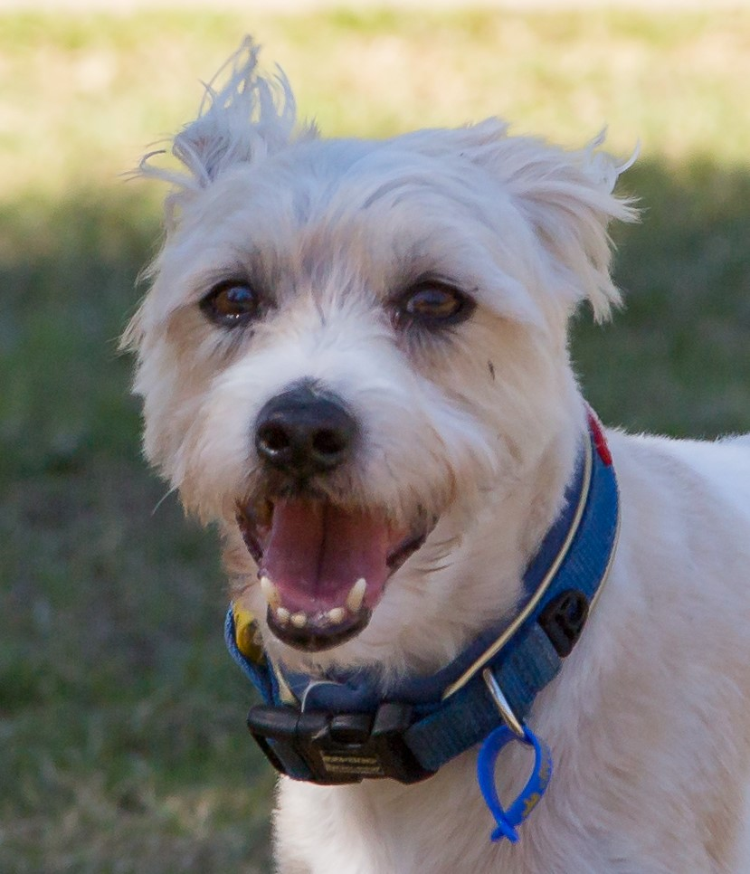

Dear Neighbour,

You may not be aware that your dog/s is making a lot of noise. The barking is causing a nuisance for surrounding residents and rather than making a complaint, I just wanted to let you know that it’s starting to impact on our lifestyle.

Brisbane City Council has provided this letter to assist in mutually resolving the matter. I have decided to let you know about your dog/s, as I am sure you would like the opportunity to resolve this matter yourself.

Typically, your dog/s is barking at these times:

Date:

Barking start time:

Barking stop time:

This appears to happen when:

Date:

Barking start time:

Barking stop time:

This appears to happen when:

Date:

Barking start time:

Barking stop time:

This appears to happen when:

Other information:

Attached is a fact sheet from Council which may help identify why your dog is barking and possible solutions to reduce the or stop the noise.

For more detailed information and tips on how to stop excessive animal noise, you can visit [www.brisbane.qld.gov.au](http://www.brisbane.qld.gov.au) and search ‘animal noise’ in the search menu.

Regards,

Your neighbour.